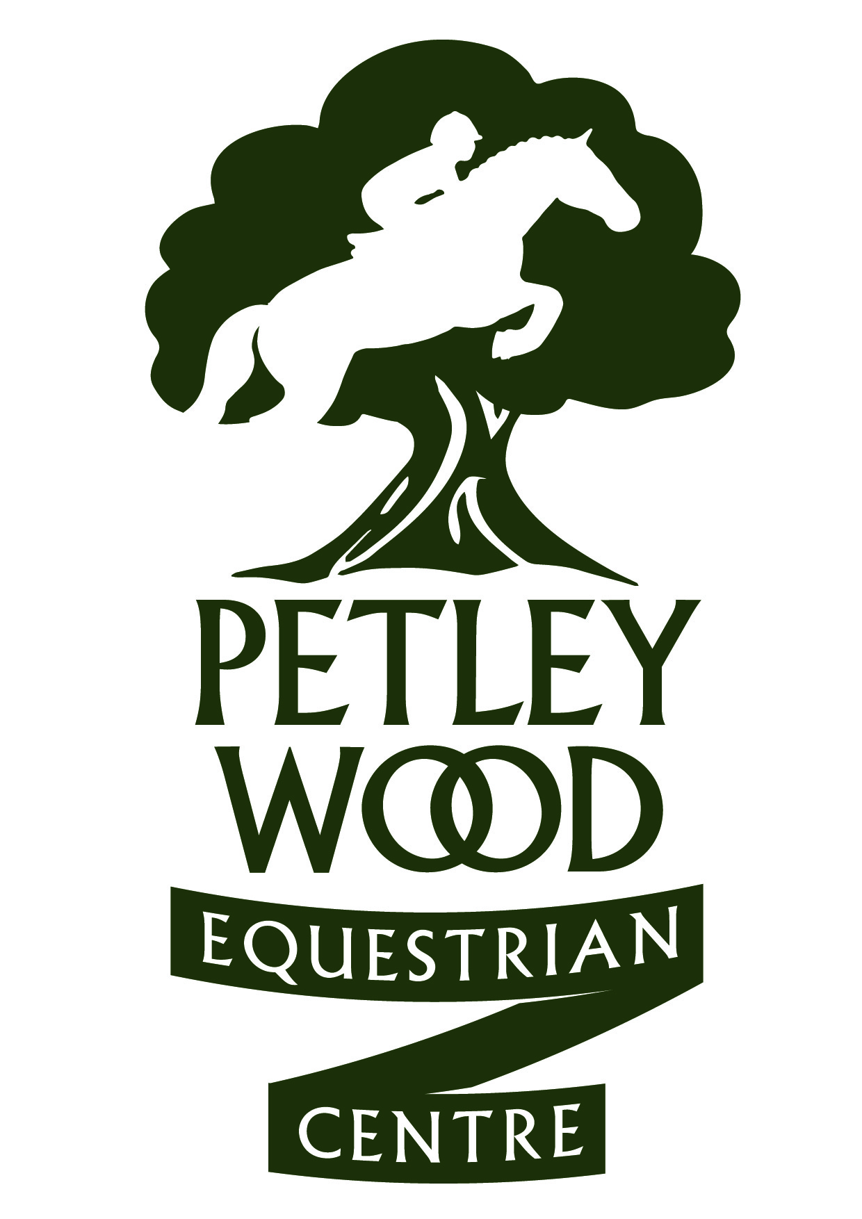

SOUTH OF ENGLAND UNAFFILIATED SJ GOLD FINAL QUALIFIERS
FINAL ON 16TH APRIL 2017
Updated: 4 APRIL 17
HORSE | RIDER
Mr Ross | Rebecca Powell Jackson
Jet Ski | Briony Clark
Secret Squirrel | Lauren Carr
Hector | Gerogia Brady
Hazel | Amelia Cameron-Clark
Basil Brush | Connie Gregory
Maximus | Hannah Griffin
First Edition | Kate Dipper
Secret Squirrel | Lauren Carr
Whiskey | Phoebe Gale
Basil Brush | Connie Gregory
Jet Ski | Briony Clark
KNIGHTWOOD WISH | LIZZIE MORTON
MARLEY | MOLLY WILLIAMS
CHLOE | SALLY RANDLES
RUBY LIGHTS | LIZZIE CLARKE
CRACKER | DEBORAH SHILLABER
MILLPARK HOUDINI | EMILY MORRIS
FINN | AMELIA DIPPER
ROCKHILL HONEY BUNNY | LOUISE SLAUGHTER
BLACKBIRD | CHARLOTTE RICA SMIT
SACKVILLE RUFUS | AMELIA DIPPER
CULMORE JJ | DINAH SMITH
TSH AFTER EIGHT | NATALIE LIGHT
SECRET SQUIRREL | LAUREN CARR
GALAXY | WENDY PURDIE
BACARDI | PAIGE WILLARD
FIRST EDITION | HARRIET DIPPER
BUSSEL | PENNY ANDERSON
ROXY | JENNY STRENHATZ
VONDEL | PENNY HERRING
GRANTSTOWN SANDMAN | SHANE CARTER
MAXIMUS | CATH FOWDREY
JOEY SUSSEX | CATH FOWDREY
TSH AFTER EIGHT | NATALIE LIGHT
UPPERTOWN WINGS | CELIA SAVELL
JEWELS ROX | LAUREN McLUSKEY
MTOTO | DEBBIE STOUT
DIZ | HAYLEY CRUSH
THE RAINDANCER | BEARTRICE ALLAWAY
KITTY | GRACE CLARKE
BLACKBIRD | CHARLOTTE RICA SMIT
LILLY | JENNY STERNHOLTZ
TANDY | LISA PILBEAM
KIZZY | HATTIE BUNDAY
DIAMOND | JENNY DIXON
IT’S JUST BEECH | LISA COPPER
BERTIE | ANNA HILTON
FLYNN | LUCY WHEELER
PENNY | JENNY BOORMAN
RUBY LIGHTS | LIZZIE CLARKE
JJ | CICELY RICE WILSON
JOEY SUSSEX | CATH FOWDREY
BISCUIT | CATH FOWDREY
THE RAINDANCER | BEATRICE ALLAWAY
KIZZY | HATTIE BUNDAY
HERO | LAURA WAGNER
PENNY | LISA PILBEAM
LLANARTH STARS AND STRIPES | REBECCA CRAWFORD
CALLISTO III | ARRAN LOUISE HOLLETT
DIAMOND | JENNY DIXON
DIZ | HAYLEY CRUSH
ALBIE | NICOLA STEED
CALVIN | AVRIL VERHAGEN
LAND OR SEA | GRACE CLARKE
CASPER | CHARLOTTE BULL
UPPERTOWN WINGS | CELIA SAVELL
MILLPACK HOUDINI | EMILY MORRIS
FRANKIE | BETHANY MAXWELL
RUBY | ANIA COX
IT’S JUST BEACH | LISA COOPER
DIBA | ROHAN CADNEY-MOON
Culmore JJ | Dinah Smith
Coco | Eleanor Simes
Homer Bear | Ellen Shepperd
Tiptoe | Leah Faircloth
Nola | Eleanor Simes
Cheeky Casper | Charlotte Bull
Misty | Sacha Hourigan
Maximus | Cath Fowdrey
Benny | Sacha Hourigan
Tictac | Rosie Wheeler
Land or Sea | Grace Clarke
Basil Brush | Connie Gregory
Kizzy | Hattie Bunday
Pepper | Lauren Brian Davis
Smokey | Hannah Williams
Jewels Rox | Anya White
Kizzy | Hattie Bunday
Callisto | Arran Hollett
Joey Sussex | Cath Fowdrey
Herbie | Eleanor Simes
What the Spot | Ben Hanson
Penteran Birthday Girl | Emily Costain
Baleer DHI | Claire Drey Brown
Bertie | Anna Hilton
Come Along Springtime | Jenny Rowlinson
Ben | Amy Hilton
POLLY | CHARLOTTE BULL
HE’S A CRACKER | EVIE WAKELING
MALIBE O LA LA | SARAH HEYNES
HERBIE | LIZ JONES
ROYAL LUX | LUCY WILSON
GUESS THE WORD | HARRISON CLARKE
CHEEKY CASPER | CHARLOTTE BULL
JEWELS ROX | ANYA WHITE
POLLY | CHARLOTTE BULL
HE’S A CRACKER | EVIE WAKELING
MR JACKSON | MILLIE WHITE
HERBIE | LIZ JONES
PEBBLY BLACK MARKET | IMOGEN EDWARDS
CHARLIE | ANNA LEVY
THE SUMMIT | JEMIMAH BERKELEY
HEY MICKEY | ANTONIA WALLACE
MALLIBEE O LALA | SARAH HEYNES
MARTIN S | HENRIETTA MEDDINGS
THE RAINDANCER | BEARTICE ALLAWAY
SEAMUS | AMELLIA CAMERON CLARKE
COSIMO | JOELEY ELPHICK
HIGHLINE TEATIME | ROELLY HAMLET
PADDY | EVELYN RAMUS
MASTER JB IMP | NICKI LLOYD
ROSSCORNELL ROCK HOPPER
IM A RASCAL | EMILY MOORE
LILY | ISABELLE STEPHEN
ASHLEYS LAD | KATHRYN EVANS
GIN | LISA BAKER
PARCHAL PENNY | ELLIE DULEY
GENIE | SOPHIE KILLICK
GREY ROSE GLORY | ALEXIA MARZA
ROO | HOLLY WHITE
DANTE | DANIELLE PADMORE

