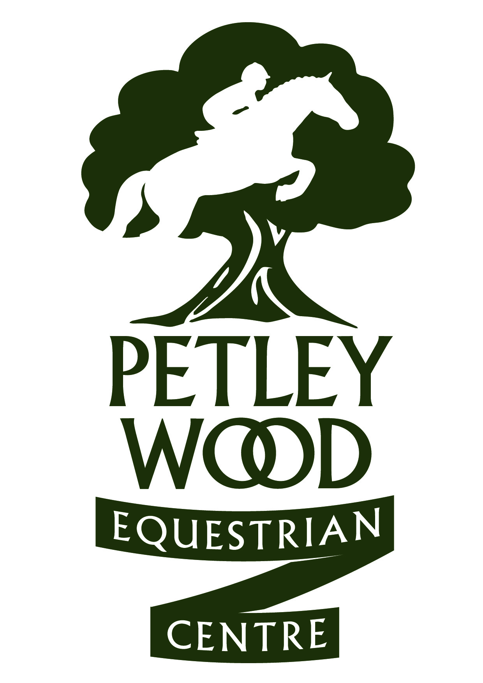

SOUTH OF ENGLAND UNAFFILIATED SJ SILVER FINAL QUALIFIERS
FINAL ON 16TH APRIL 2017
Updated: 4 APRIL 17
HORSE | RIDER
Jack | Lucy Smith
Boo | Mia Stack
Clover Chip | Vicky Perks
Hamilton Magic Poppy | Emily Martin
Hector | Georgia Brady
CULMORE JJ | DINAH SMITH
FLORAC | NEVE GREGORY
CASPER | CHARLOTTE BULL
WILDERNESS GALAXY | WENDY PURDIE
SILVER | AVRIL VERHAGEN
BON CORSIDA | KIM TAYLOR
HOPPER | MIA WATERMAN
DIBA | ROHAN CADNEY-MOON
ANT | NICOLA STEED
HERBIE | ELIZABETH JONES
KNIGHTWOOD WISH | LIZZIE MORTON
MARLEY | MOLLY WILLIAMS
CHLOE | SALLY RANDLES
RUBY LIGHTS | LIZZIE CLARKE
CRACKER | DEBORAH SHILLABER
MILLPARK HOUDINI | EMILY MORRIS
FINN | AMELIA DIPPER
ROCKHILL HONEY BUNNY | LOUISE SLAUGHTER
BLACKBIRD | CHARLOTTE RICA SMIT
SACKVILLE RUFUS | AMELIA DIPPER
CULMORE JJ | DINAH SMITH
TSH AFTER EIGHT | NATALIE LIGHT
SECRET SQUIRREL | LAUREN CARR
GALAXY | WENDY PURDIE
BACARDI | PAIGE WILLARD
FIRST EDITION | HARRIET DIPPER
BUSSEL | PENNY ANDERSON
ROXY | JENNY STRENHATZ
VONDEL | PENNY HERRING
GRANTSTOWN SANDMAN | SHANE CARTER
TOMMY | PHOBE GALE
KIRI | MEGAN VERHAGEN
BROOKSHILL CUTIE | MADDIE WATERS
PHOEBE | SOPHIE HOLLANDS
BENNY | CHARLOTTE BULL
PADDYS PANACHE | HOLLY HASSAAN
LAND OR SEA | GRACE CLARKE
RUBY LIGHTS | LIZZIE CLARKE
ITS JUST BEECH | LISA COPPER
BENNY | CHARLOTTE BULL
Benny | Charlotte Bull
Brookshill Cutie | Maddie Walters
Billy Eurodisney | Oliver Grainge
Tom Tom | Lauren Mc Knight
Jakes Man | Sara Cremer
Howells Bank Spring Edition | Sharon Garner
Culmore JJ | Dinah Smith
Bon Corseadina | Kim Taylor
Lola | Maisie Goodsell
Robin Rooster | Allisya Fattore
Mister Tom | Polly Hutton
Batman | Holly Smith
Cookie | Jack Cosgrove
Lilly | Jasmine Wilks
Misty Miss | Alexandra Williams
Jetski | Briony Clarke
Pepsi Cola | Katie Reuben
Betsy | Archie Cosgrove
Finn | Jasmine Wilks
Little Miss Mystery | Katy Laver
Jack | Hayley Gow
Crystal Dorada Lisa | Lily Chandler
Misty | Sacha Hourigan
Maximus | Cath Fowdrey
Benny | Sacha Hourigan
Tictac | Rosie Wheeler
Land or Sea | Grace Clarke
Basil Brush | Connie Gregory
Kizzy | Hattie Bunday
Pepper | Lauren Brian Davis
Smokey | Hannah Williams
Jewels Rox | Anya White
NIMBUS FLYER | JANE HOWARD
HOWELLS BANK SPRING EDITION | SHARON GARNER
MALIBE O LALA | SARAH HEYNES
EFS FOX LITTLE LOTS | SOPHIE POULTER
GUESS THE WORD | HARRISON CLARKE
PADDY | ROSIE CHAPLIN
PADDYS PANACHE | HOLLY HASSAN
CRYSTAL DERRADA LISA | FLO MC KAY
NIMBUS FLYER | JANE HOWARD
PEBBLY BLACK MARKET | IMOGEN EDWARDS
MALLIBEE O LALA | SARAH HEYNES
HECTOR | COLLEEN DENNIS
POPPINGHOLE TOTENTOSUM | CARLY FROGGAT
THE SUMMIT | JEMIMAH BERKLEY
CODY | JESS KEATLEY PALMER
TILLY | KAYA MARCHANT
CHASE | PARIS CRAMP
LEXI | HAZEL JABBITT
ROYAL LUX | LUCY WILSON
THE RAINDANCER | BEARTICE ALLAWAY
SEAMUS | AMELLIA CAMERON CLARKE
COSIMO | JOELEY ELPHICK
HIGHLINE TEATIME | ROELLY HAMLET
PADDY | EVELYN RAMUS
MASTER JB IMP | NICKI LLOYD
DORA | PIPPA CHALLINOR
SPIRIT OF FLANDERS | EMILY PAICE
QUILL | ALYANA EVEREST
FRIVVY | ELLA RICHARDSON
BOYSIE | JULIE WILLIAMS
L’ART DU SILENCE | SALLY MOIR
OSCAR | JULIET LANGDON DOWN
WINNIE | MARNIE BASSI
GREY ROSE GLORY | ALEXIA MARZA
DIBA | MARNIE BASSI

